**Ques 1**:

<html>

<head>

<title>My Resume</title></head>

<body>

<img src="D:\passport size\gurpreet.jpeg" align="left" width="100" height="110">

<dl>

<dt><font size="+1"><b>Gurpreet Kaur Jassal</b></font></dt>

<dt>305/5 Patel Nagar,</dt>

<dt>Dehradun-248001, Uttarakhand, India</dt>

<dt><b>Email id :</b> gurpreetkaurjassal@icloud.com</dt>

<dt><b>Phone No :</b> +917017660739</dt>

<dt>https://www.linkedin.com/in/gurpreetjassal31/</dt>

</dl>

<hr>

<ul>

<li>A final year student pursing Bachleor of Computer Applications program.</li>

<li>Looking forward to secure work with an organization that offers a reliable positive climate to learn and actualize new skills for the improvement of the association.</li>

<li>An opportunity grabber with growth-oriented mindset.</li>

<li>Have good understanding of OOP concepts.</li>

<li>Enthusiastic about developing apps on Android Studio.</li>

<li>Love doing intricate mandalas, playing Badminton, listening music, travelling and a lots of other things!.</li>

</ul>

<h3>ACADEMIC QUALIFICATION</h3>

<table align="center" border="1" valign="middle" cellpadding="10" cellspacing="10" >

<tr><th>Name of Program</th><th>Institute</th><th>Board/University</th><th>Year of Passing</th><th>Percentage</th></tr>

<tr align="middle"><td>BCA</td><td>Graphic Era Hill University, Dehradun</td><td>Graphic Era Univeristy</td><td>Expected 2023</td><td>86%</td></tr>

<tr align="middle"><td>Intermediate</td><td>Sandal Wood School, Uttarakhand</td><td>ISC</td><td>2020</td><td>87.8%</td></tr>

<tr align="middle"><td>High School</td><td>Sandal Wood School, Uttarakhand</td><td>ICSE</td><td>2018</td><td>89.6%</td></tr>

</table>

<h3>TECHNICAL SKILLS</h3>

<ul>

<li>Core Java</li>

<li>DBMS(Database Management System),SQL</li>

<li>Microsoft Office(MS Word, MS Excel, PowerPoint, etc)</li>

<li>Basic knowledge of Tally</li>

</ul>

<h3>PERSONAL SKILLS</h3>

<ul>

<li>Proven leadership skills and ability to motivate</li>

<li>Highly organized and efficient</li>

<li>Ability to work independently or as a part of team</li>

<li>Keen to learn new things</li>

</ul>

<h3>ACHIEVEMENTS AND OTHER ACTIVITIES</h3>

<ul>

<li>Patent on 'An Application to help Local Businesses and Dealers'</li>

<li>Annual Topper's Award-2021,Achiever's Award 2021</li>

</ul>

<h3>CERTIFICATIONS</h3>

<ul>

<li><b>COURSERA:</b> Java for Android</li>

<li><b>COURSERA:</b> Android App Components - Intents, Activities, and Broadcast Receivers</li>

</ul>

<h3>PERSONAL DETAILS</h3>

<ul>

<li>Father's Name: Baldev Singh Jassal</li>

<li>Date of Birth: 31 May 2002</li>

<li>Gender : Female</li>

<li>Languages : Hindi, English and Punjabi</li>

</ul>

</body>

</html>

**OUTPUT:**

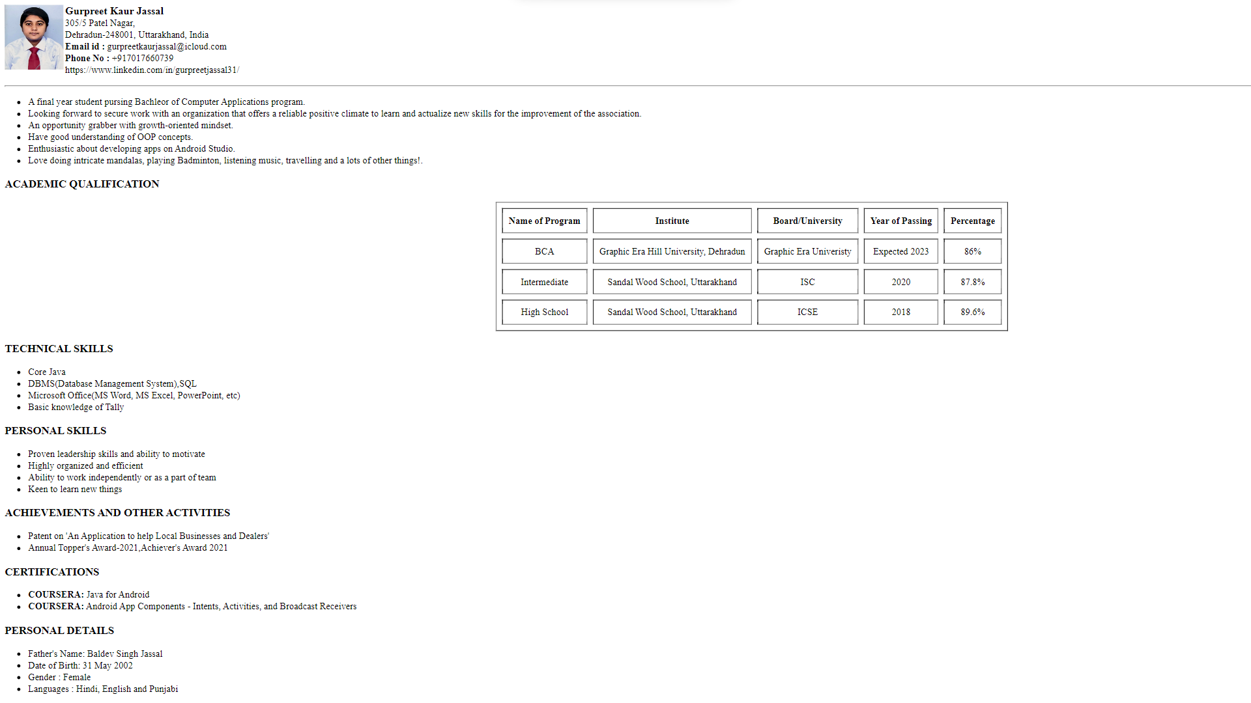

**Ques 2:**

<html>

<head>

<title>Time Table</title></head>

<body>

<h1>COURSE: BCA 5</h1>

<hr>

<table align="center" border="1" valign="middle" cellpadding="10" cellspacing="10" >

<tr><th>DAYS</th><th>8:00-8:55</th> <th>8:55-9:50</th> <th>10:10-11:05</th> <th>11:05-12:00</th> <th>12:00-12:55</th> <th>12:55-1:50</th> <th>2:10-3:05</th> <th>3:05-4:00</th> <th>4:00-4:55</th> <th>4:55-5:50</th> </tr>

<tr align="middle"><td>MON</td> <td></td> <td></td> <td></td> <td></td> <td>TBC 506</td> <td></td> <td>TBC 505</td> <td>TBC 503</td> <td></td> <td></td> </tr>

<tr align="middle"><td>TUE</td> <td colspan="2">PBC 501</td> <td>TBC 501</td> <td>TBC 506</td> <td>TBC 505</td> <td></td> <td>XBI 501</td> <td></td> <td></td> <td></td> </tr>

<tr align="middle"><td>WED</td> <td></td> <td></td> <td></td> <td></td> <td></td> <td>TBC 503</td> <td>TBC 501</td> <td>TBC 502</td> <td></td> <td></td> </tr>

<tr align="middle"><td>THU</td> <td></td> <td></td> <td></td> <td></td> <td>TBC 502</td> <td></td> <td>TBC 501</td> <td>TBC 505</td> <td></td> <td></td> </tr>

<tr align="middle"><td>FRI</td> <td>TBC 503</td> <td>TBC 506</td> <td></td> <td></td> <td colspan="2">PBC 502</td> <td>XBC 501</td> <td>TBC 505</td> <td></td> <td></td> </tr>

<tr align="middle"><td>SAT</td> <td></td> <td></td> <td></td> <td></td> <td></td> <td></td> <td></td> <td></td> <td></td> <td></td> </tr>

<tr><th colspan="2">CODE</th> <th colspan="4">SUBJECTS</th> <th colspan="3">FACULTY</th> <th colspan="2">L T P C</th> </tr>

<tr align="middle"><td colspan="2">TBC 501</td> <td colspan="4">Web Development</td> <td colspan="3">MS. DEEPTI NEGI</td> <td colspan="2">3003</td> </tr>

<tr align="middle"><td colspan="2">TBC 502</td> <td colspan="4">Mobile Application Development</td> <td colspan="3">MS. PRIYA KOHLI</td> <td colspan="2">3003</td> </tr>

<tr align="middle"><td colspan="2">TBC 503</td> <td colspan="4">Cryptography</td> <td colspan="3">MS. NIDHI JOSHI</td> <td colspan="2">3104</td> </tr>

<tr align="middle"><td colspan="2">TBC 504</td> <td colspan="4">Software Engineering</td> <td colspan="3">ONLINE</td> <td colspan="2">3003</td> </tr>

<tr align="middle"><td colspan="2">TBC 505</td> <td colspan="4">Internet of things</td> <td colspan="3">MR. ADITYA HARBOLA</td> <td colspan="2">3003</td> </tr>

<tr align="middle"><td colspan="2">TBC 506</td> <td colspan="4">Financial Accounting</td> <td colspan="3">DR. MEGHA</td> <td colspan="2">3003</td> </tr>

<tr align="middle"><td colspan="2">XBI 501</td> <td colspan="4">Career Skills-III</td> <td colspan="3">MS. SULEKHA</td> <td colspan="2">2002</td> </tr>

<tr align="middle"><td colspan="2">PBC 501</td> <td colspan="4">Web Development & Internet of Things</td> <td colspan="3">MS. DEEPTI NEGI, MR. ADITYA HARBOLA</td> <td colspan="2">0042</td> </tr>

<tr align="middle"><td colspan="2">PBC 502</td> <td colspan="4">Mobile Application Development</td> <td colspan="3">MS. PRIYA KOHLI</td> <td colspan="2">0042</td> </tr>

<tr align="middle"><td colspan="2">SBC 501</td> <td colspan="4">MOOC based seminar</td> <td colspan="3">MS. PRIYA KOHLI</td> <td colspan="2">0001</td> </tr>

<tr align="middle"><td colspan="2">GP 501</td> <td colspan="4">General Proficiency</td> <td colspan="3">MS. PRIYA KOHLI</td> <td colspan="2"></td> </tr>

</table>

</body>

</html>

OUTPUT:

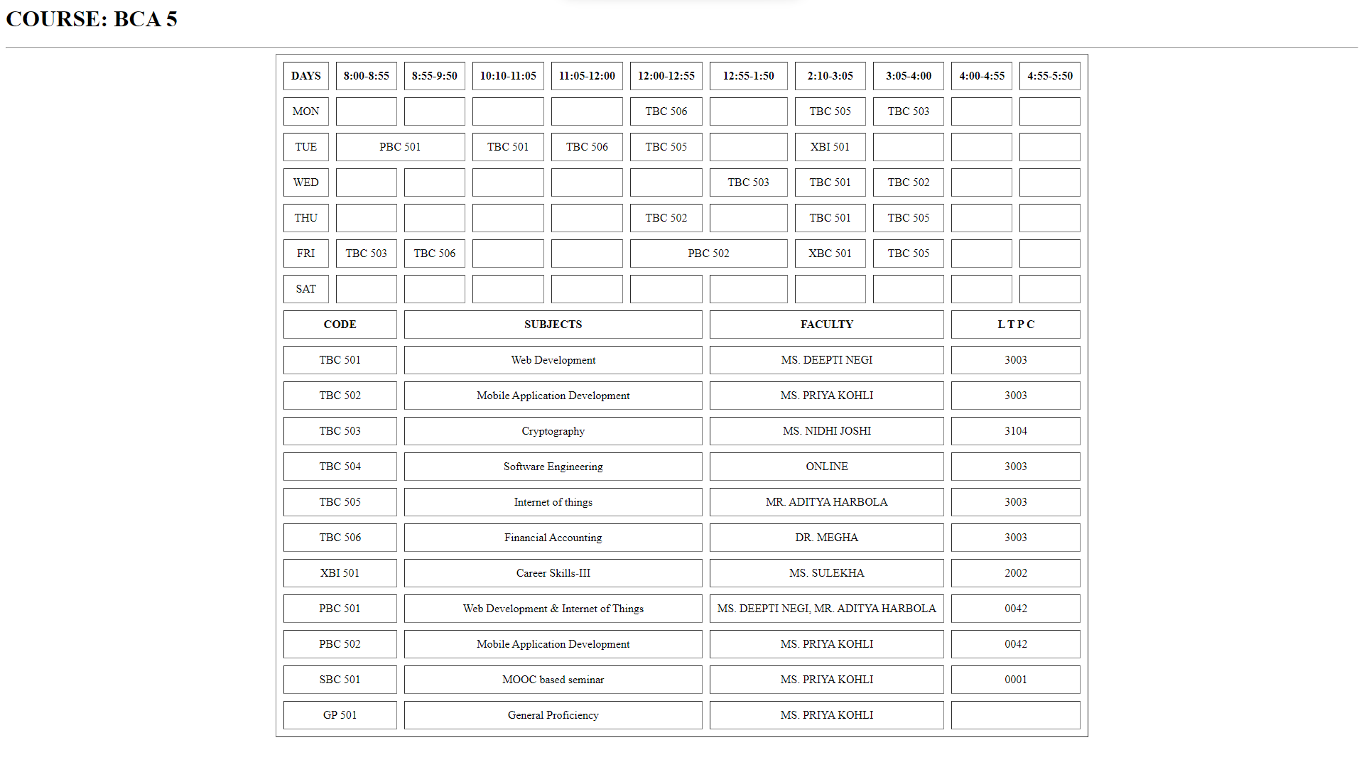

**Ques 3**: INTERNAL HYPERLINKING

<!DOCTYPE html>

<html>

<head>

</head>

<body>

<h3>

<a href="#lession1">What is Computer?</a><br />

<a href="#lession2">Register Memory</a><br />

<a href="#lession3">Internet</a><br />

<a href="#lession4">Intranet</a><br />

<br /></h3>

<a id="lession1"><h2>What is Computer?</h2></a>

<p>A computer is a programmable electronic device that accepts raw data as input and processes it with a set of instructions (a program) to produce the result as output. It renders output just after performing mathematical and logical operations and can save the output for future use. It can process numerical as well as non-numerical calculations. The term "computer" is derived from the Latin word "computare" which means to calculate.</p>

<p>A computer is designed to execute applications and provides a variety of solutions through integrated hardware and software components. It works with the help of programs and represents the decimal numbers through a string of binary digits. It also has a memory that stores the data, programs, and result of processing. The components of a computer such as machinery that includes wires, transistors, circuits, hard disk are called hardware. Whereas, the programs and data are called software.</p>

<p>It is believed that the Analytical Engine was the first computer which was invented by Charles Babbage in 1837. It used punch cards as read-only memory. Charles Babbage is also known as the father of the computer.</p>

<p><strong>The basic parts without which a computer cannot work are as follows:</strong>

<ul><li>Processor: It executes instructions from software and hardware.</li>

<li>Memory: It is the primary memory for data transfer between the CPU and storage.</li>

<li>Motherboard: It is the part that connects all other parts or components of a computer.</li>

<li>Storage Device: It permanently stores the data, e.g., hard drive.</li>

<li>Input Device: It allows you to communicate with the computer or to input data, e.g., a keyboard.</li>

<li>Output Device: It enables you to see the output, e.g., monitor</li> </ul></p>

<br />

<br />

<div id="lession2"><h2>Register Memory</h2></div>

<p>Register memory is the smallest and fastest memory in a computer. It is not a part of the main memory and is located in the CPU in the form of registers, which are the smallest data holding elements. A register temporarily holds frequently used data, instructions, and memory address that are to be used by CPU. They hold instructions that are currently processed by the CPU. All data is required to pass through registers before it can be processed. So, they are used by CPU to process the data entered by the users.</p>

<p>Registers hold a small amount of data around 32 bits to 64 bits. The speed of a CPU depends on the number and size (no. of bits) of registers that are built into the CPU. Registers can be of different types based on their uses. Some of the widely used Registers include Accumulator or AC, Data Register or DR, the Address Register or AR, Program Counter (PC), I/O Address Register, and more.</p>

<p>Types and Functions of Computer Registers:</p>

<p><ul>

<li><b>Data Register:</b> It is a 16-bit register, which is used to store operands (variables) to be operated by the processor. It temporarily stores data, which is being transmitted to or received from a peripheral device.</li>

<li><b>Program Counter (PC):</b> It holds the address of the memory location of the next instruction, which is to be fetched after the current instruction is completed. So, it is used to maintain the path of execution of the different programs and thus executes the programs one by one, when the previous instruction gets completed.</li>

<li><b>Instructor Register:</b> It is a 16-bit register. It stores the instruction which is fetched from the main memory. So, it is used to hold instruction codes, which are to be executed. The Control Unit takes instruction from Instructor Register, then decodes and executes it.</li>

<li><b>Accumulator Register:</b> It is a 16-bit register, which is used to store the results produced by the system. For example, the results generated by CPU after the processing are stored in the AC register. </li>

<li><b>Address Register:</b> It is a 12-bit register that stores the address of a memory location where instructions or data is stored in the memory.</li>

<li><b>I/O Address Register:</b> Its job is to specify the address of a particular I/O device.</li>

<li><b>I/O Buffer Register:</b> Its job is to exchange the data between an I/O module and the CPU.</li></ul></p>

<br />

<br />

<p id="lession3"><h2>Internet</h2></p>

<p>Internet is a global network that connects billions of computers across the world with each other and to the World Wide Web. It uses standard internet protocol suite (TCP/IP) to connect billions of computer users worldwide. It is set up by using cables such as optical fibers and other wireless and networking technologies. At present, internet is the fastest mean of sending or exchanging information and data between computers across the world.</p>

<p>It is believed that the internet was developed by "Defense Advanced Projects Agency" (DARPA) department of the United States. And, it was first connected in 1969.</p>

<p>Internet is called a network as it creates a network by connecting computers and servers across the world using routers, switches and telephone lines, and other communication devices and channels. So, it can be considered a global network of physical cables such as copper telephone wires, fiber optic cables, tv cables, etc. Furthermore, even wireless connections like 3G, 4G, or Wi-Fi make use of these cables to access the Internet.</p>

<p>Internet is different from the World Wide Web as the World Wide Web is a network of computers and servers created by connecting them through the internet. So, the internet is the backbone of the web as it provides the technical infrastructure to establish the WWW and acts as a medium to transmit information from one computer to another computer. It uses web browsers to display the information on the client, which it fetches from web servers.</p>

<p>The internet is not owned by a single person or organization entirely. It is a concept based on physical infrastructure that connects networks with other networks to create a global network of billions of computers. As of 12 August 2016, there were more than 300 crores of internet users across the world.</p>

<br />

<br />

<article id="lession4"><h2>Intranet</h2></article>

<p>The intranet is a private network that belongs to a particular organization. It is designed for the exclusive use of an organization and its associates, such as employees, customers, and other authorized people. It offers a secure platform to convey information and share data with authorized users. Confidential information, database, links, forms, and applications can be made available to the staff through the intranet. So, it is like a private internet or an internal website that is operating within an organization to provide its employees access to its information and records. Each computer in intranet is identified by a unique IP Address.</p>

<p>It is based on internet protocols (TCP/IP) and is protected from unauthorized access with firewalls and other security systems. The firewall monitors the incoming and outgoing data packets to ensure they don't contain unauthorized requests. So, users on the intranet can access the internet, but the internet users can't access the intranet if they are not authorized for it. Furthermore, to access the intranet, the authorized user is required to be connected to its LAN (Local Area Network).</p>

<p>Intranet basically comprises three components: a web server, an intranet platform, and applications. The web server is hardware that contains all the intranet software and data. It manages all requests for files hosted over the server and finds the requested files and then delivers it to the user's computer.</p>

<p>The intranet platform, which is software, allows communication tools, collaboration apps, and databases to work seamlessly with each other. It is tailored to the specific needs of a business.

The applications are required to enable users to work smoothly. They are the computing tools that allow users to do their work, communicate, and coordinate with each other and retrieve and store information.

Furthermore, the user who wants to access the intranet is required to have a special network password and should be connected to the LAN. A user who is working remotely can gain access to the intranet through a virtual private network (VPN) that allows them to sign in to the intranet to access the information.</p>

</body>

</html>

OUTPUT:

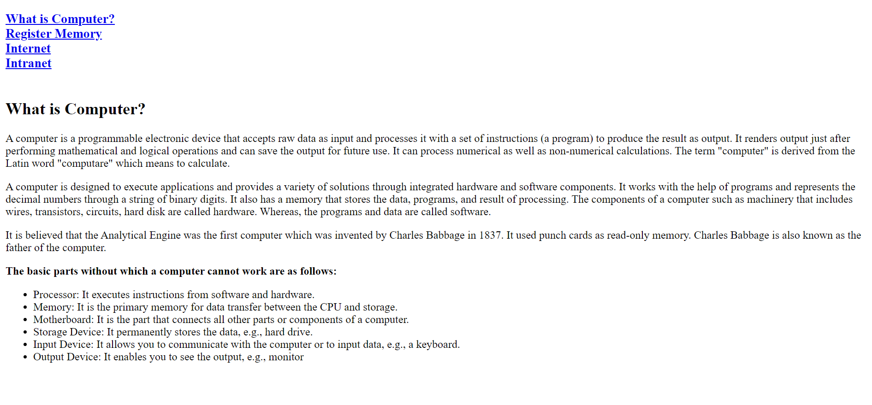

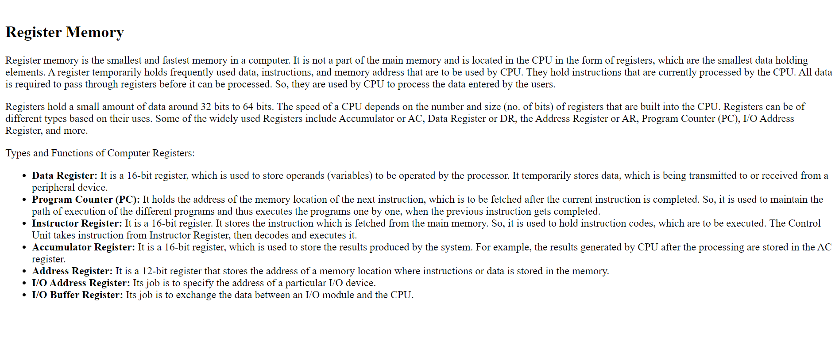

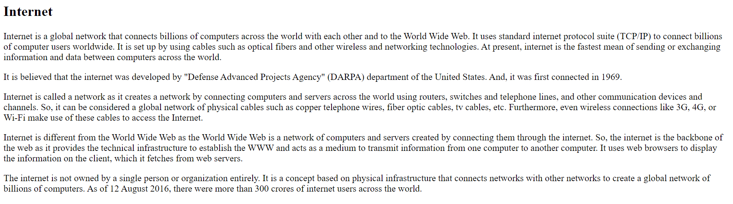

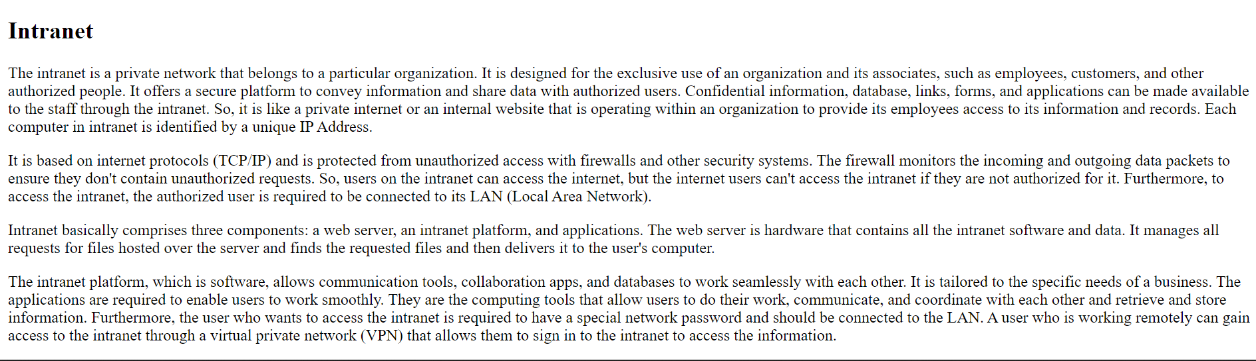

**Ques 4**: EXTERNAL HYPERLINKING

<! DOCTYPE html>

<html>

<head>

<title> HTML Internal links </title>

</head>

<body>

<h1>HTML: HyperText Markup Language</h1>

<ul>

<li>History of the web</li>

<li>History of HTML versions</li>

</ul>

<p>Tim Berners-Lee invented the first browser at CERN, to enable researchers to share their research with each other.</p>

<p>

<img src="https://www.kasandbox.org/programming-images/misc/tim-berners-lee-webpage.png" width="200">

<br>Image courtesy CERN

</p>

<h2>History of the web</h2>

<ul>

<li><strong>1989: The motivation</strong>

<p>CERN Physicist Tim Berners-Lee needed “a pool of information which could grow and evolve with the organisation and the projects it describes.”

<br>

<a href="http://www.w3.org/History/1989/proposal.html">Read the original proposal</a>

</p>

</li>

<li>

<strong>1989: The invention</strong>

<p>Berners-Lee invented the World Wide Web, HTTP, and wrote the <a href="http://www.w3.org/History/19921103-hypertext/hypertext/WWW/TheProject.html">first HTML page</a>.

</p>

</li>

<li>

<strong>1993: It starts small</strong>

<p>Berners-Lee presented the WWW at the IETF conference in a small BoF session, which is mentioned in the <a href="http://www.ietf.org/proceedings/26.pdf">proceedings</a>.</p>

</li>

<li>

<strong>1993: It gets bigger!</strong>

<p>NCSA creates the free <a href="http://www.ncsa.illinois.edu/enabling">Mosaic" browser</a>, and adds bookmarks, images, and a better UI.</p>

</li>

<li>

<strong>1993+: The explosion</strong>

<p>The number of domains increased as the internet started being <a href="http://en.wikipedia.org/wiki/History_of_the_Internet#Opening_the_network_to_commerce">used by commerce</a>.</p>

</li>

<li><strong>1994: The World Wide Web Consortium</strong>

<p>Berners-Lee founds the W3C to standardize HTML for all browsers to follow.</p>

</li>

</ul>

<h2>History of HTML versions</h2>

<ul>

<li>1995: HTML 2.0</li>

<li>1997 (Jan): HTML 3.2</li>

<li>1997 (Dec): HTML 4.0</li>

<li>1999: HTML 4.01</li>

<li>2004: "HTML5" is proposed by WHATWG, a new committee</li>

<li>2008: HTML5 is adopted by W3C as a standard.</li>

</ul>

<p>Read more on <a href="http://en.wikipedia.org/wiki/HTML#HTML_versions_timeline">Wikipedia</a></p>

</body>

</html>

OUTPUT:

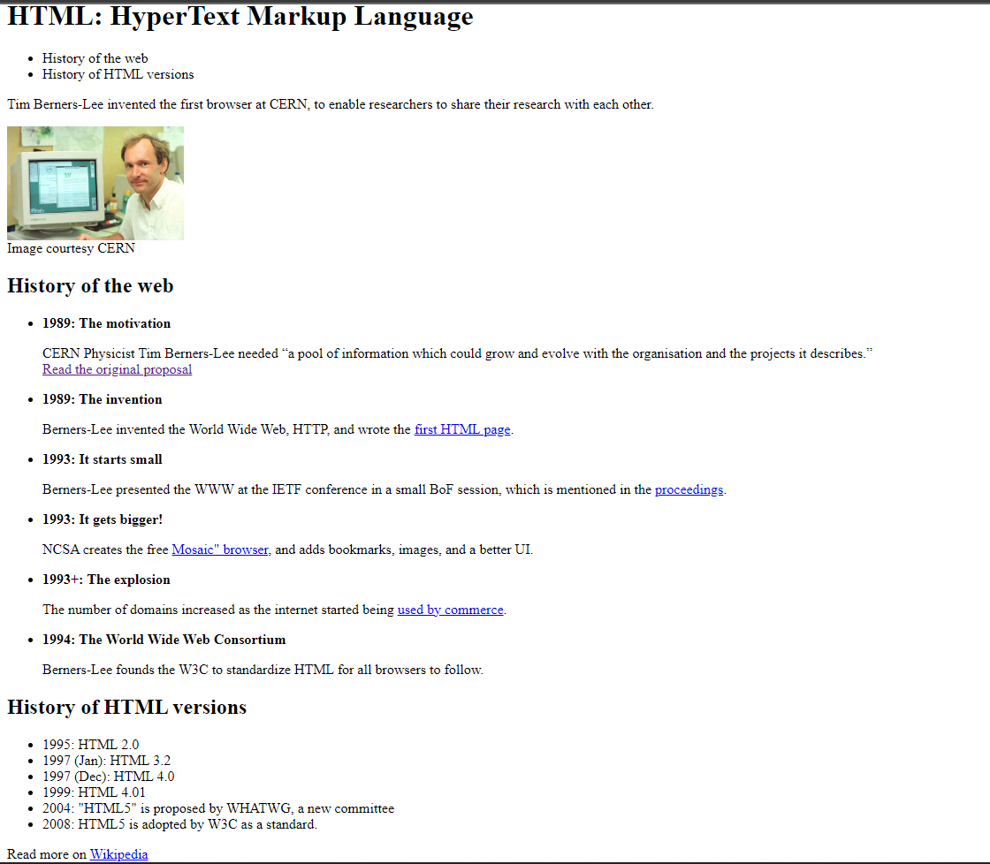

**Ques 5**: IMAGE MAPPING

<!DOCTYPE html>

<html>

<head>

</head>

<body>

<div class="box">

<img src="D:\pICS\image-map-in-html.jpg" usemap="#workmap" width="1000" height="667">

<map name="workmap">

<area shape="rect" coords="300,103,710,545" alt="Computer" href="https://www.apple.com/in/macbook-pro/" target="_blank">

<area shape="rect" coords="720,337,800,434" alt="Phone" href="https://www.apple.com/in/shop/buy-iphone/iphone-13" target="_blank">

<area shape="circle" coords="854,445,44" alt="Coffee" href="https://www.cafecoffeeday.com/cafe-menu/whats-new" target="_blank">

<area shape="rect" coords="0,382,255,500" alt="notebook" href="https://www.cafecoffeeday.com/cafe-menu/whats-new" target="_blank">

</map>

</div>

</body>

</html>

OUTPUT:



